**Physics 30 ­– Lesson 20**

**Magnetic Forces, Charged Particles.**

Possible 82/74

1) A permanent magnet involves the alignment of magnetic domains, while an electromagnet depends on current around a solenoid.

/2

2)

The Left Hand Rule (karate grip) is where fingers point in the direction of the magnetic field, thumb points in direction of the particle’s initial motion, and the palm indicates the direction of the force. The **force** is directed **out of the page**.

N

/2



S

3)

Only the right hand aligns with the magnetic field direction, velocity and force on the particle. Therefore it is a **positive** charge.

#1

x

F

v

B

/3

The particle is not affected by the magnetic field. Therefore it has **no charge**.

#2

x

v

F

B

#3

Only the left hand aligns with the magnetic field direction, velocity and force on the particle. Therefore it is a **negative** charge.

4)

/3 

5)

The magnetic force is a centripetal force, therefore it changes the direction while speed remains constant.

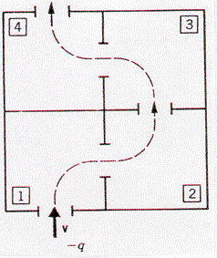

x x x x

x x x x

x x x x x

x x x x

x x x x

x x x x x

. . . . . . . .

. . . .

. . . . . . . .

. . . .

/6

6)



/3

7) Since  and , no force is applied the electron is unaffected

/2

8)



/3

9)





10)



/5

11)

Direction

For the right hand: fingers point upward, thumb points south – palm points **west**.



/4



12)

/6



13)



/4

14)



/6

15)



d = ?

r

Bonus

/8

The particle follows a corkscrew path with a radius (r) and a distance (d) between adjacent rotations in the magnetic field. The velocity is broken into vertical and horizontal components. The vertical component is used to calculate the radius (r) and period (T) of rotation and the horizontal component is used to find (d).



16)



undeflected means

Fm = Fe

•

Fm

Fe



17)







look up the element with an atomic mass of 40 on the periodic table – ion is Ca2+